Final Project write up Data Science
Ankit Daga

Introduction
Being a major financial burden on the economy, diabetes affects millions of Americans annually and is one of the most common chronic diseases in the US. The same can be said for diseases like heart disease and stroke, which may also leave lingering damage to the patient after they experience it. All of this can lead to a serious loss of quality of life and as well as the reduction of one’s life expectancy. Rather than being able to treat them, it is then more important to prevent these conditions among people who may be likely to fall victim to them. While there are things like genetics that are out of anyone’s control, there are factors like diet, exercise, mental health and overall lifestyle choices of an individual that we have active control over that can drastically change the trajectory of someone’s life. Thus, this project aims to reveal such factors that may be highly associated with these diseases. Using 2015 survey data from the center of disease control (cdc), we used classification models to investigate important factors associated with each disease. Results found that decision trees were the best model for finding important features that were specific for each disease.

Methods
The dataset utilized was a cleaned dataset of values obtained from a Kaggle user that derived it from a survey from responses collected by The Behavioral Risk Factor Surveillance System (BRFSS) from over 400,000 Americans on health-related risk behaviors, chronic health conditions, and the use of preventative services ever since 1984. This specific cleaned up dataset was obtained from the year 2015. The goal of using this dataset was to examine what are the factors highly correlated with causing diseases/conditions like diabetes, heart disease and stroke. Since the owner of the dataset had already cleaned and processed the data, this step was not required to complete.
The models chosen were logistic regression, decision tree and random forest to classify using the dataset whether someone did or did not have any of the mentioned diseases.
For each disease, the datasets were split to feature data, containing everything except data for the disease (diabetes/heart disease/stroke) and the target data containing only the disease.
The data underwent train test split where 20% was allocated for testing data and scaling (StandardScaler).
Scaled data was modeled using each of the models mentioned and a confusion matrix, accuracy score and feature of importance was calculated for them.
Accuracy score was used to decide on best model for each disease and confusion matrix helped take a look at the distribution of predicted data of the model compared to true data. Feature importance was especially important as it helped elucidate what was the biggest effector for the disease.
Results

Diabetes Analysis

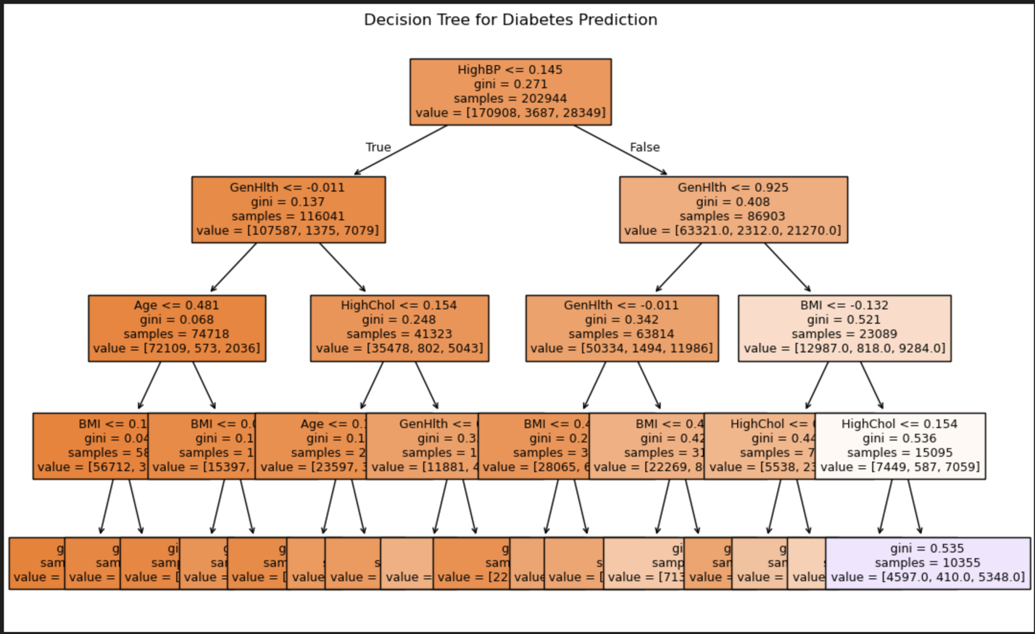
Figure 1: Decision Tree model for diabetes. Accuracy score was 0.848.

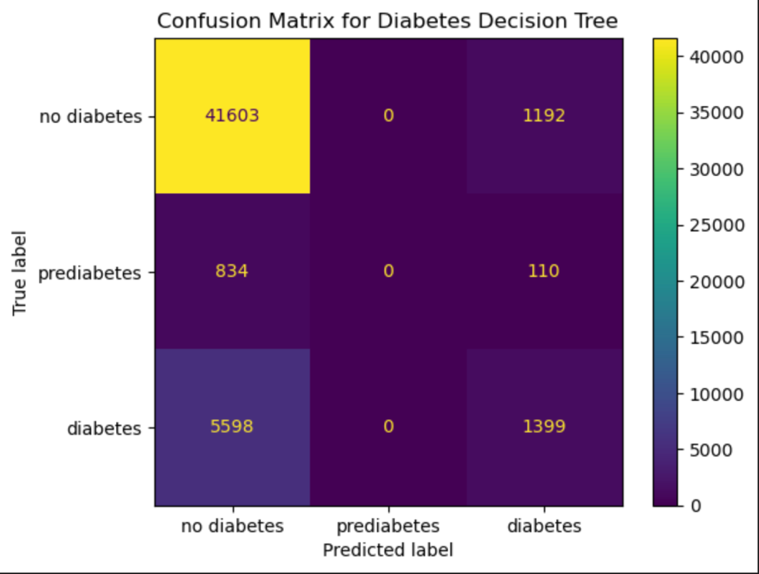
Figure 2: Confusion Matrix for decision tree model
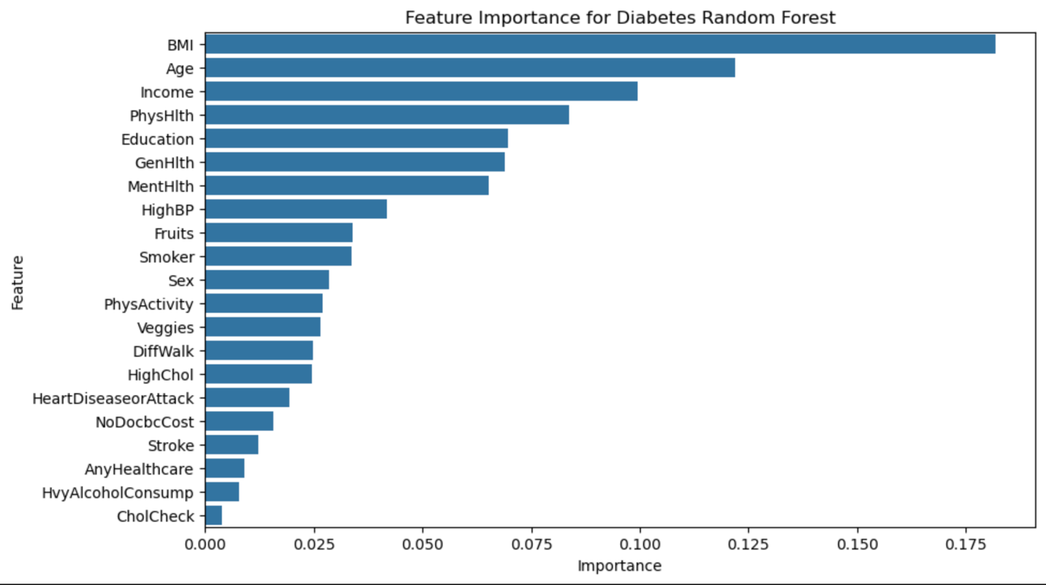
Figure 3: Feature importance graph for diabetes from random forest model. BMI found to be most important feature.

Among all the models used for diabetes, decision tree had the highest accuracy score, being 0.848. However, the accuracy scores for each of the models were not really significantly different. For feature importance, looking at the random forest model found BMI to be the most important factor when looking at diabetes. However, when looking at decision tree and logistic regression, it was high blood pressure and income respectively.

Stroke Analysis
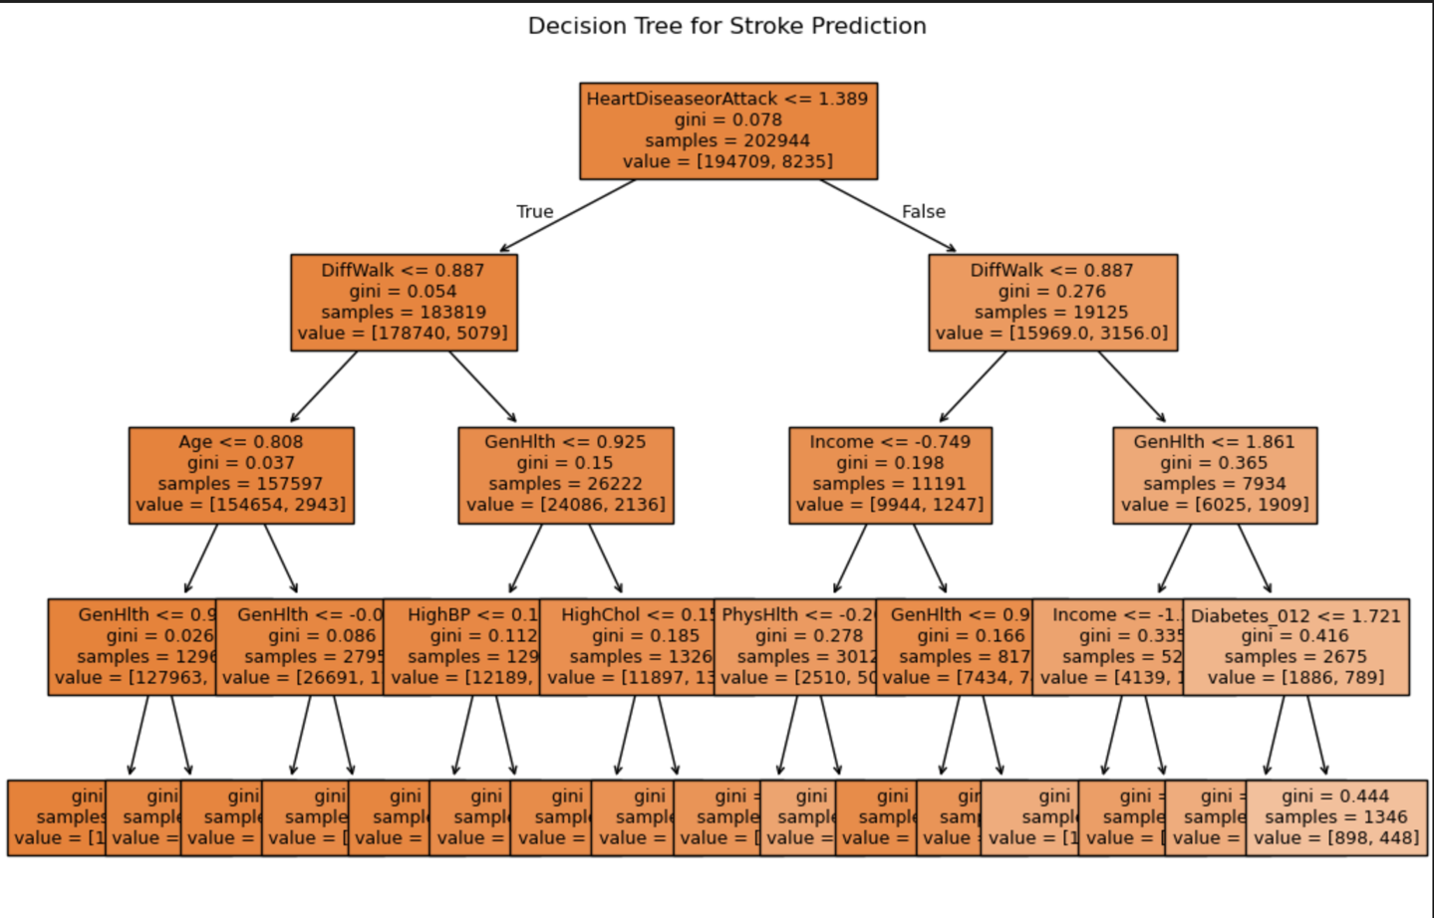
Figure 4: Decision tree model for stroke.

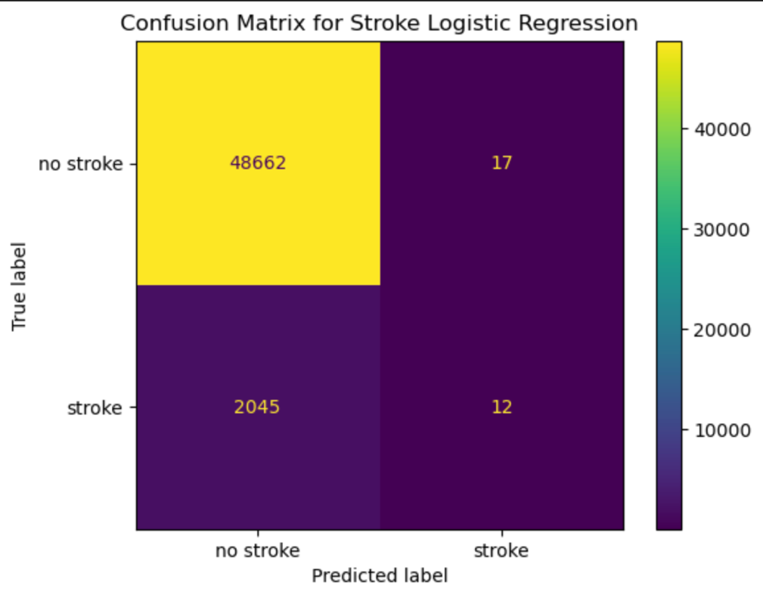
Figure 5: Confusion matrix for logistic regression model of stroke. Accuracy score was 0.959.
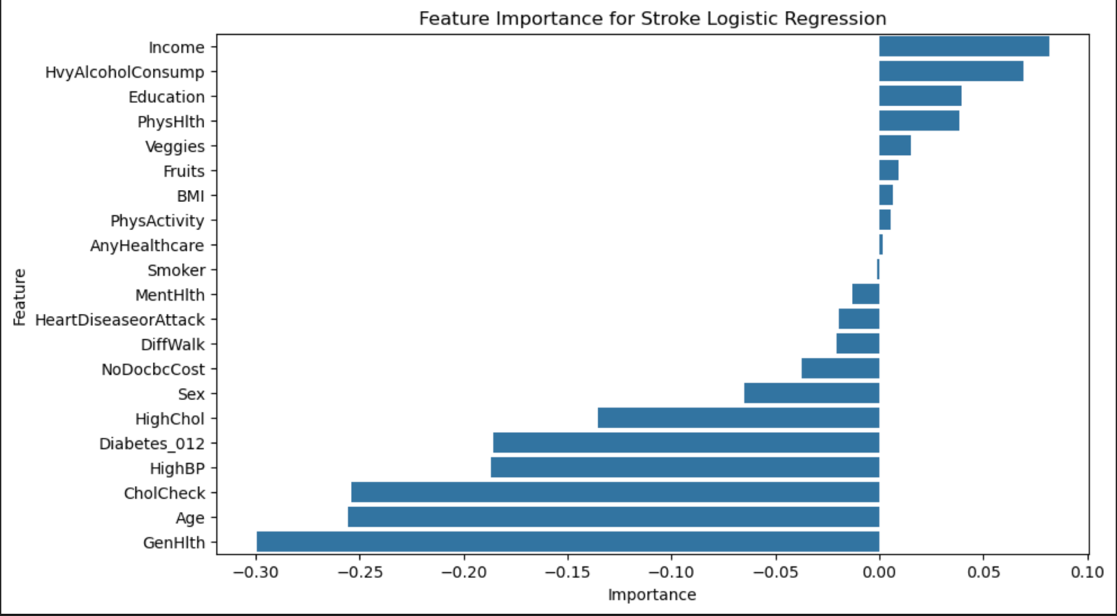
Figure 6: Feature importance graph for stroke from logistic regression model. Income found most important feature.

Logistic regression was found to have the highest accuracy for stroke, being 0.959. For feature importance, looking at the logistic regression as shown in figure 6 found income to be the most important factor whereas decision tree and random forest found blood pressure and BMI to be most important.

Heart Disease Analysis
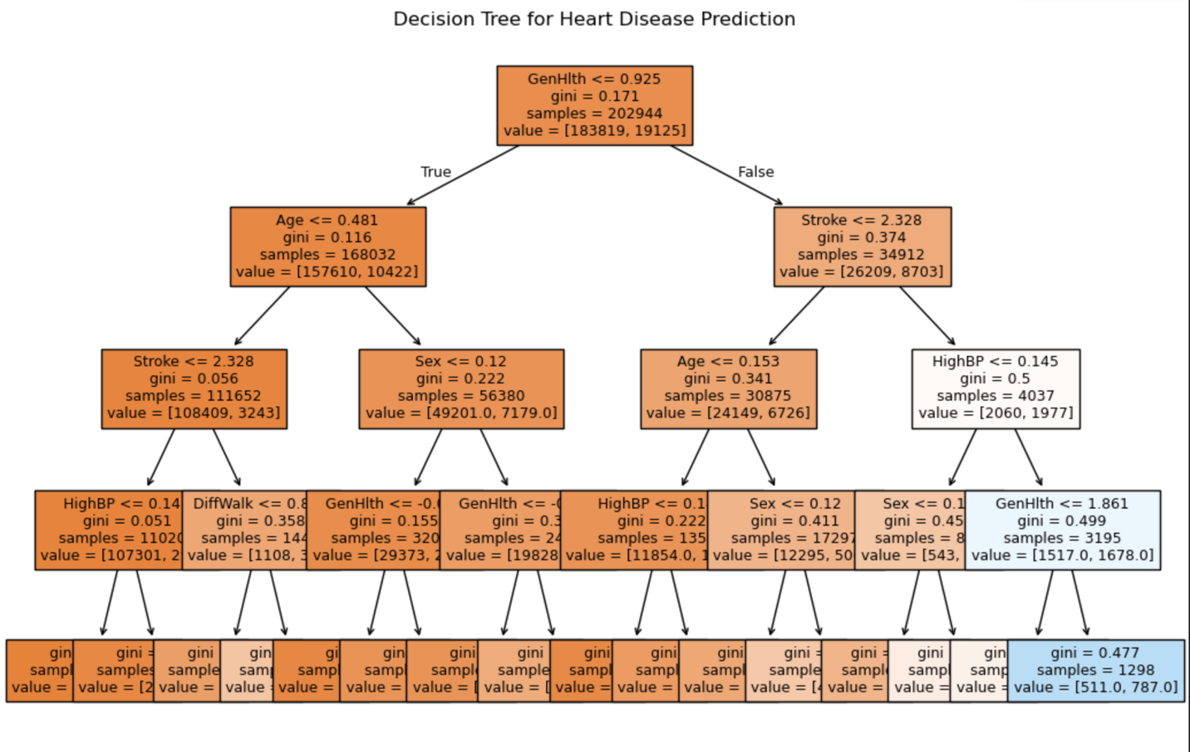Figure 7: Decision tree model for heart disease. Accuracy score was 0.908.

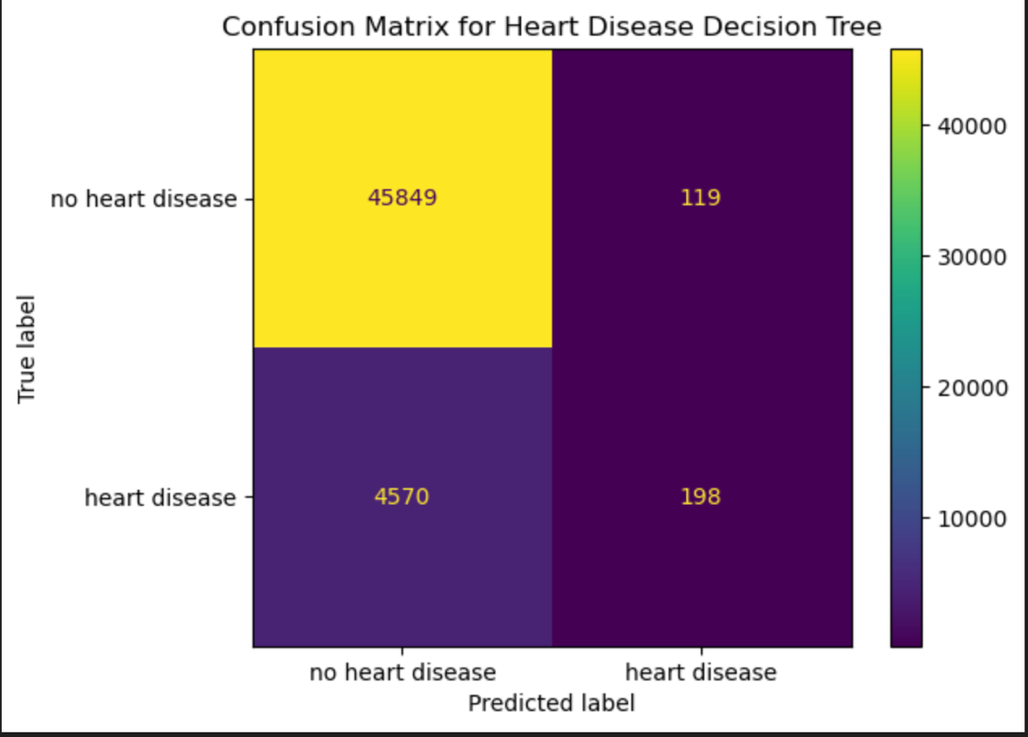
Figure 8: Confusion matrix for decision tree model of heart disease.

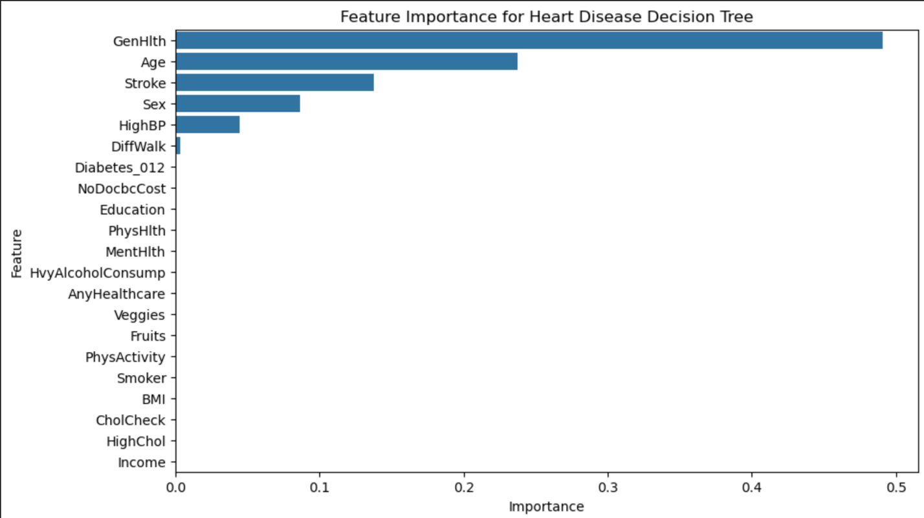
Figure 9: Feature importance graph for heart disease. Having had a heart disease was found to be most important feature.

There was no significant difference in accuracy scores between models, but decision tree was found to have the highest accuracy. Feature importance of decision tree found general health to be the most important feature while income and BMI were the most important for logistic and random forest respectively.

Discussion
Overall, it can be said that the analyses were able to give some ideas of what factors were important for each of the diseases. An important detail observed about feature importances was that for all the diseases, all the feature important graphs for random forests and logistic regression were identical. While we are not sure why this was observed, it may indicate that the nature of these models may not be the best fit if they are not able to reveal important features that are specific with respect to the disease. On the other hand, feature graphs from the decision model for each disease was very different for each of them, which was much more informative in realizing important factors for each disease. We also saw for that heart disease was the most important feature for stroke, telling us that some of the diseases could be related to one another and that having a history with one may lead to another. In the case of logistic regression, perhaps minimizing the amount of feature used using something like lasso regression could be useful in pointing out the key features specific for each disease. As regularization is not used for random forest and decision tree, tuning out the hyperparameters may help improve the results for both as well. Such projects may help build the groundwork for predictive models to diagnose someone with diabetes or heart disease and may also help them take the steps for prevention.

